CSAdmin Run Book

Document Category: RB

Version: 2.2.5.x

Status:<>

Last Updated: May 14th, 2018

Contents

Contents 2

1 Introduction 3

1.1 Purpose 3

1.2 Scope 3

1.3 Target Audience 3

2 Installation and Setup 4

2.1 Installation 4

2.1.1 Pre-requisites 4

2.1.2 Migration/Installation Steps 4

2.2 Setup & Configurations 11

2.2.1 Dependent software and service configuration 11

2.2.2 RAC System Configuration 11

3 Operations Procedure 12

3.1 Basic Operations 12

3.1.1 Start-up and Initial Validation 12

3.1.2 Shutdown 12

3.2 Monitoring 13

3.2.1 Reactive steps 13

3.2.2 Escalation Steps 13

Approvals 15

History 16

# Introduction

## Purpose

The purpose of this document is to provide install and operational guidelines for the CSAdmin system and will specifically cover the following topics:

* Installation
* Environment preparation
* Install and post install verification
* Configuration & setup
* Operations Procedures
* startup/shutdown/restart
* Operational Monitoring
* Basic troubleshooting & Escalation

## Scope

The RAC system fits in with the school separately from the other systems. It doesn’t rely on other systems, however all of the other system in the college rely on it to provide authorization to access that system. The system also relies on Clara and Active Directory to take in users and assign roles. They system also has it’s own database that it uses to store applications, roles, and local users.

## Target Audience

This document is intended for use as a reference by infrastructure engineers and system operators responsible for the installation and subsequent operational support of the CSAdmin system and related systems.

# Installation and Setup

## Installation

### Pre-requisites

Before installing CSAdmin, please make sure the following environmental requirements are met.

#### Hardware Requirements:

|  |  |  |
| --- | --- | --- |
|  | **Application Server** | **Database** |
| **CPU** | 1Ghz | N/A |
| **RAM** | 512MB | N/A |
| **Disk Space** | 50 MB | 5GB |

CSAdmin is not CPU or memory intensive, however these values could vary. These are rounded up to ensure smooth performance.

#### Software Requirements:

|  |  |
| --- | --- |
| **Application Server** | **Database** |
| Windows server 2008 | Windows server 2008 |
| Internet Information Services (IIS) 6 | RedGate |
| Visual Studio 2010 | SQL Server 2008 |
| Team Foundation Server (TFS) 2013 |  |
| ASP.NET 4.5 |  |

Note: The procurement and install process of the required third party hardware & software components mentioned above is outside the scope of this run book and is not described.

### Migration/Installation Steps

#### Installation:

Log in as a user that has the proper privileges required to install

Step 1: Configuring your application.

1. Open Visual Studio.
2. Connect to the CSTFS server and select the CSAdmin-2018-MR-Team1 solution. Map and Get the solution.
3. Open the CSAdmin project’s Web.config file.
4. Under the “<connectionStrings>” element, add a new connection string to the database that you wish to connect to.

Step 2: Deploying to a server.

* 1. In the solution explorer, right click on the CSAdminMVC project. Select “Publish”.
  2. Open the connection settings.

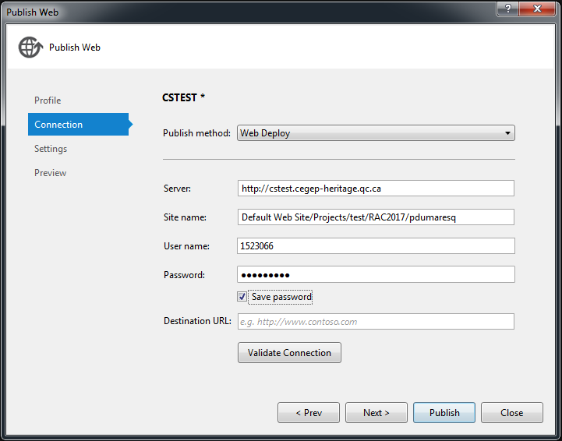

* 1. Enter the information for the application server which you want to publish to and enter your credential.
  2. Click on the settings tab for database configurations.
  3. Configure each of the databases as such: Leaving the “Remote Connection String” blank and checking “Use this connection string at runtime”.

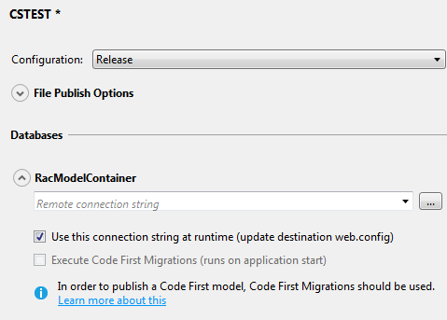

* 1. Click “Publish”.
  2. Connect to the server that you deployed to using “Remote Desktop Connection”

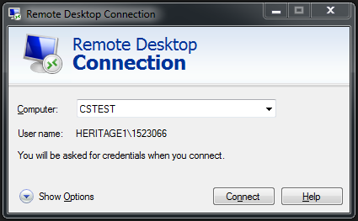

* 1. Open up the Server manager.

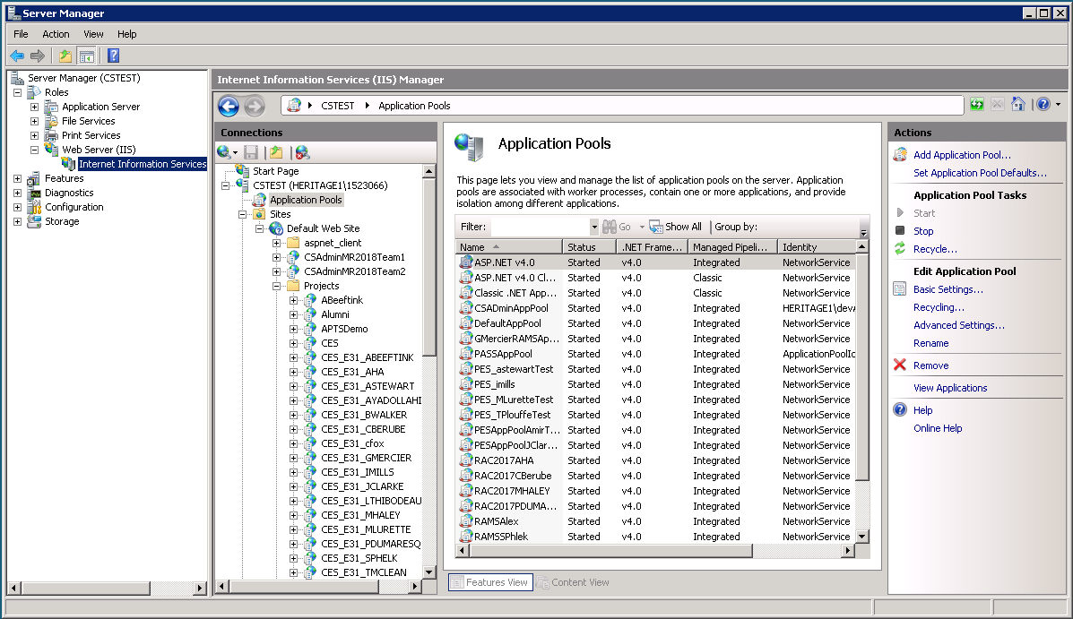

* 1. Navigate to the “Internet Information Service (IIS) Manager”
  2. Navigate to the “Application Pools”
  3. Under “Actions” in the right panel, select “Add Application Pool”.
  4. Name it and make sure the “.NET Framework Version” is 4.x and the “Managed Pipeline Mode” is set to “Integrated” and click “OK”.
  5. Right-click the App Pool you just made and select “Advanced Settings”.
  6. Change the “Identity” to “NetworkService” and click “OK”.

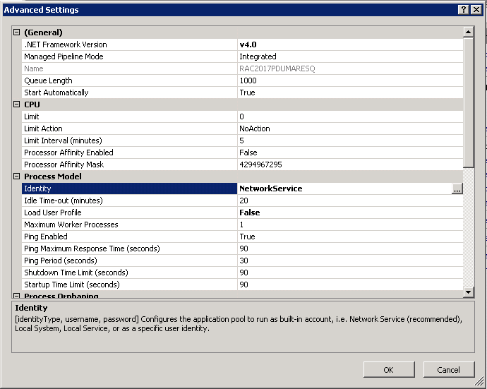

* 1. Navigate to the directory of the website you added in step d.

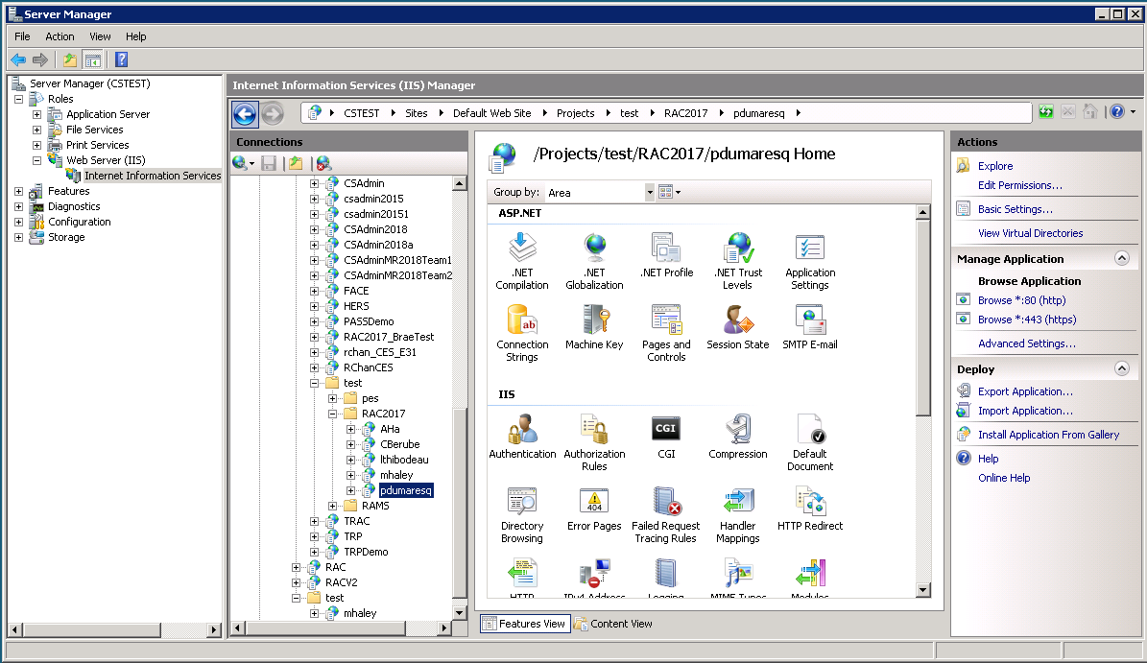

* 1. Click the “Advanced Settings”, change the “Application Pool” to the new pool that you just added in step n.

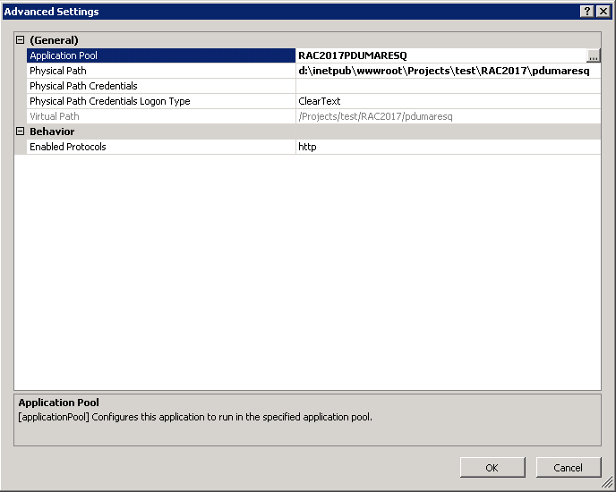

#### Post Installation verification steps:

* 1. Open SQL Server Management Studio
  2. Connect to the target database server you entered in your connection strings.
  3. Expand the database to make sure all the following tables exist.

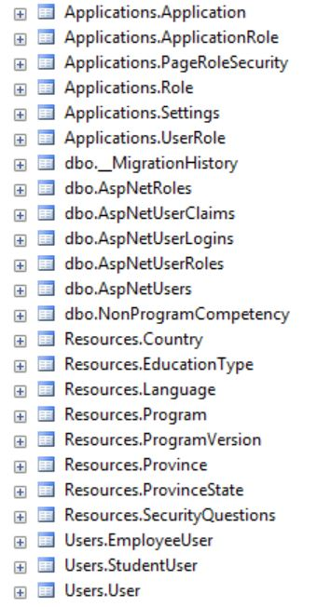

* 1. Open up a web browser.
  2. Navigate to [http://[server_name]/[virtualPath_seenIn2.1.2.1StepD](http://[server_name]/%5bvirtualPath_seenIn2.1.2.1StepD)]
  3. Log in with a profile that has access the CSAdmin administrator role and make sure it works.

## Setup & Configurations

### Dependent software and service configuration

* CSAdmin needs to have an AppPool created for it
* CSAdmin needs to be added to the AppPool once it’s been created.

### RAC System Configuration

The configuration for the system is done within the web.config file inside the solution. This is an XML file and contains various settings for database connection strings and variables used throughout the solution. The file can be found in the root of the CSAdmin project within the solution.

|  |  |  |  |
| --- | --- | --- | --- |
| **Key Name** | | **Example Value** | **Notes** |
| <connectionStrings | | | |
| LDAPConnectionString | LDAP://DC01.cegep-heritage.qc.ca | | The LDAP server in case RAC advisor users require it. |
| CSAdminContext | Metadata=res://*/RACModels… | | The target database server that was deployed to. |
| CSAdminUsers | metadata=res://*/CSAdminModel… | | The authentication system used for the RAC advisor |
| <appSettings> | | | |
| NoReply | | A string value in email form | The email address that sends automated emails to users. |
| SmtpHost | | A string value as a server address | The mail server address that the college uses for emails. |

Table 2‑1 Example Dependent Service Configuration

# Operations Procedure

## Basic Operations

### Upgrading the System

The Entity Framework for the system uses a code first approach. As such, if the system upgrades include changes to the classes, then all of the user data will need to be backed up beforehand. Pushing the changes out to the database will require removing the content of all of the tables, so you need to ensure that all the data is backed up prior.

Without having any code changes, then upgrading the application in production is as simple as re-deploying the web site to the application server following the steps included above in part 2.1.2.1.

## Monitoring

### Escalation Steps

#### Escalation Order

Please escalated to the middleware team if required in the order mentioned below starting from top

|  |  |  |
| --- | --- | --- |
| Team | Hotline/Phone number | Distribution list |
| IT Service | (819) 778-2270 x2045 |  |
| Bernard Dupond | (819) 778-2270 X2043 | [bdupont@cegep-heritage.qc.ca](mailto:bdupont@cegep-heritage.qc.ca) |
| Marc Amey | (819) 778-2270 x2042 | [mamey@cegep-heritage.qc.ca](mailto:mamey@cegep-heritage.qc.ca) |
| Allan McDonald | (819) 778-2270 x2071 | [amcdonald@cegep-heritage.qc.ca](mailto:amcdonald@cegep-heritage.qc.ca) |

**Table 3‑1 Service Escalation Contact**

#### Stake Holders Contact

Stake holders contact to notify an outage or any other issue (impending or occurred)

|  |  |  |
| --- | --- | --- |
| Team | Primary Hotline/Phone number | Primary Distribution list |
| Allan McDonald | (819) 778-2270 x2071 | [amcdonald@cegep-heritage.qc.ca](mailto:amcdonald@cegep-heritage.qc.ca) |

**Table 3‑2 Stake Holders Contact**

Approvals

This document has been read and approved by the following people, responsible for its implementation. Approval is indicated by an email showing approval. Those approving below indicate that the contents of this document are correct and complete and agree to their implementation:

| Title | Name | Approval |
| --- | --- | --- |
|  |  |  |
|  |  |  |
|  |  |  |
|  |  |  |

History

| Version | Status | Date | Author | Reason for changes |
| --- | --- | --- | --- | --- |
| 1.1 | Pending approval | April 13th 2018 | Philip Dumaresq | Initial draft of the runbook |
| 1.2 | Pending Approval | April 24th 2018 |  | Competed version of initial runbook |
|  |  |  |  |  |
|  |  |  |  |  |
|  |  |  |  |  |